Codework #2: a)

LAB 9 23K-0068

- The rand() function is invoked prior to creating a child process with fork().
- In the child process, fork() returns 0.
- The child process prints a random number and then terminates.
- Upon termination, the child sends a SIGCHLD signal to its parent.
- The proc_exit() function is invoked when the child process ends.
- It utilizes waitpid() to confirm the child's termination.
- A message is displayed stating that the child process with PID <pid> has terminated.
- After the child has completely exited and the signal is processed, the parent process also terminates.
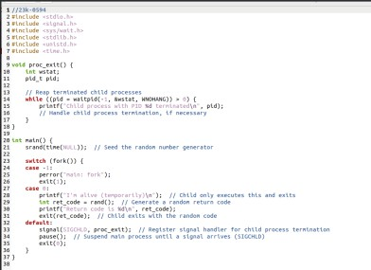
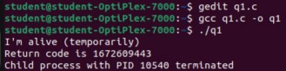

b)

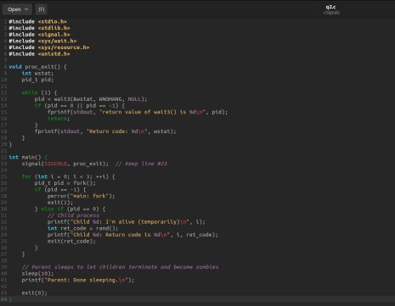
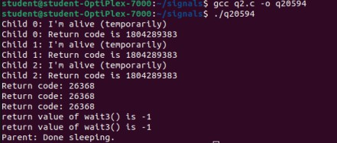
Codework #3: a)

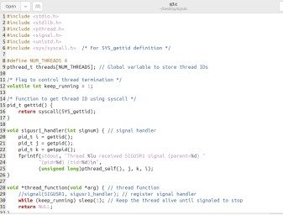
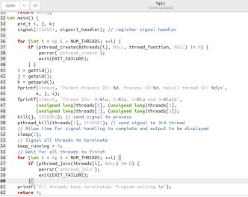
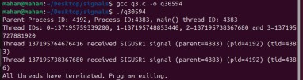

b and c)

